


PROJECT REPORT
SUDOKU GAME

- Course title : Programming in Python
- Course code : CSE 1021
      - Course type : Flipped course
      - Course credits : 3
      - Professor : Dr. SIVABALAN KR
      - Slot : B21+B22+B23+E14+E21+E22
      - Submitted by : AADHINATH G
      - Registration number : 26BAI10307
Submission date : 30/09/2026

1. INTRODUCTION
Sudoku is a logic-based number puzzle played on a 9×9 grid. The objective is to fill every empty cell with a number from 1 to 9 so that each row, each column and each 3×3 sub-grid contains every number exactly once.

This project implements a command-line Sudoku Game using Python. The program provides Easy and Medium difficulty levels, validates player moves, counts mistakes, provides help and solution commands, and uses a backtracking algorithm to generate the correct solution for the selected puzzle.

The project demonstrates practical use of Python concepts such as lists, dictionaries, functions, loops, conditional statements, input validation, recursion, random selection and backtracking.

2. PROBLEM STATEMENT
Manual Sudoku solving requires the player to continuously check rows, columns and 3×3 boxes. A computer-based version should automatically perform these checks, prevent modification of the original clues, identify incorrect moves, maintain a mistake limit and provide a solution when requested.

The problem addressed by this project is to design a simple, interactive and reliable Sudoku game in Python that manages the complete game flow while applying the rules of Sudoku programmatically.

3. OBJECTIVES
• Develop an interactive Sudoku game using Python.
• Provide multiple difficulty levels.
• Display the 9×9 Sudoku board clearly in the terminal.
• Validate every player move according to Sudoku rules.
• Prevent changes to the original puzzle clues.
• Solve puzzles automatically using backtracking.
• Track the number of empty cells and player mistakes.
• Provide help, solution, new-game and quit commands.
• Demonstrate modular programming using separate functions.

4. FUNCTIONAL REQUIREMENTS
1. Display a main menu.
2. Allow the player to select Easy or Medium difficulty.
3. Randomly select a puzzle from the selected difficulty.
4. Display the current Sudoku board.
5. Accept row, column and number as a move.
6. Validate input ranges from 1 to 9.
7. Check row, column and 3×3 box constraints.
8. Compare a valid-looking answer with the actual solved board.
9. Allow a maximum of five mistakes.
10. Display the solution on request.
11. Allow the player to request help, start a new game or quit.
12. Detect successful completion of the puzzle.

5. NON-FUNCTIONAL REQUIREMENTS
• Platform: Any system capable of running Python 3.
• Programming Language: Python.
• Interface: Command-line / terminal.
• Main library used: random.
• No external database is required.
• The program should provide clear messages for valid and invalid input.
• The program should maintain a simple and readable structure for beginner-level understanding.

6. SYSTEM ARCHITECTURE
The program follows a modular structure. The main() function controls the menu. play_game() controls one complete game session. Board display, validation, solving, input handling and help are separated into individual functions.

The major components are:
• Puzzle Data – stores Easy and Medium Sudoku puzzles.
• Main Menu – selects the game mode.
• Game Controller – manages the game loop and mistake count.
• Board Display – prints the Sudoku grid.
• Validation Module – checks rows, columns and 3×3 boxes.
• Solver Module – finds the solution using recursive backtracking.
• Input Module – validates player commands and moves.

7. WORKFLOW / FLOWCHART
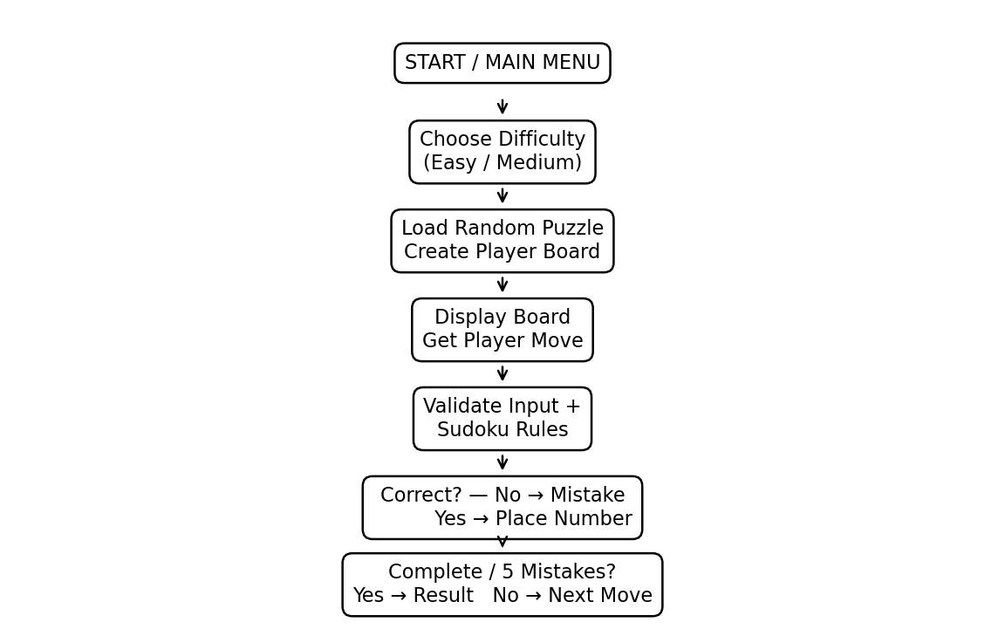

8. PROGRAM ARCHITECTURE
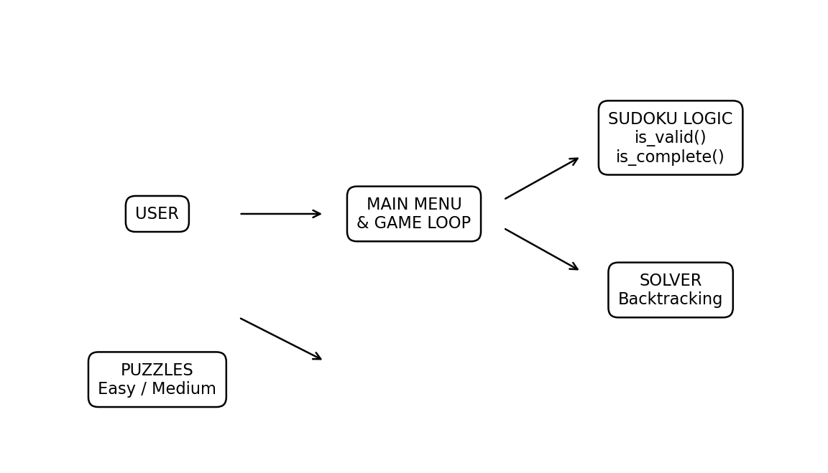

9. DESIGN AND ALGORITHM

9.1 Sudoku Validation Algorithm
1. Receive the board position (row, column) and proposed number.
2. Scan the selected row.
3. If the number already exists, reject the move.
4. Scan the selected column.
5. If the number already exists, reject the move.
6. Calculate the starting row and column of the corresponding 3×3 box.
7. Scan all nine cells in that box.
8. If the number is absent from all three checks, the placement is valid.

9.2 Backtracking Algorithm
The solve() function searches for an empty cell. It tries numbers 1 to 9 one at a time. A number is temporarily placed only when is_valid() returns True. The function then recursively attempts to solve the remaining empty cells. If a choice leads to a dead end, the number is removed and the next possible number is tried. When no empty cells remain, the puzzle is solved.

9.3 Pseudocode
START
Display main menu
Read user choice
IF Easy/Medium:
Select a random puzzle
Copy original puzzle to player board
Generate solution using backtracking
WHILE game is active:
Display board and status
Read move or command
IF command:
perform requested command
ELSE:
validate row, column and number
IF original cell:
reject move
ELSE IF Sudoku rule is violated:
increase mistakes
ELSE IF answer differs from solution:
increase mistakes
ELSE:
place number
IF board complete:
show result
IF mistakes reach 5:
show game over and solution
IF Quit:
END
END

10. IMPLEMENTATION DETAILS
Function / Component | Purpose
PUZZLES | A dictionary stores puzzles under Easy and Medium difficulty levels. A puzzle is represented as a 9×9 nested list, where 0 represents an empty cell.
print_board() | Displays the board with row and column numbers, separators and dots for empty cells.
is_valid() | Checks whether a number is absent from the selected row, column and 3×3 sub-grid.
is_complete() | Checks whether the board contains no zero values.
solve() | Uses recursive backtracking to find a valid complete Sudoku solution.
get_solution() | Creates a copy of the puzzle and solves the copy, keeping the original puzzle unchanged.
count_empty() | Counts all cells containing 0.
show_help() | Displays instructions and available commands.
get_move() | Reads the player's move, validates its format and converts row/column values to Python indexes.
play_game() | Controls puzzle selection, board state, solution checking, mistake tracking and game completion.
main() | Displays the main menu and starts the selected game mode.

11. TESTING AND SAMPLE OUTPUT
Test Case | Input | Expected Result | Status
Main menu | Enter 1 | Easy game starts | Pass
Difficulty selection | Enter 2 | Medium game starts | Pass
Valid move | 2 5 7 | Correct move accepted when it matches solution | Pass
Invalid row | 10 2 5 | Error message displayed | Pass
Invalid number | 2 5 10 | Error message displayed | Pass
Original clue | Select a filled clue | Move rejected | Pass
Rule violation | Place duplicate in row/column/box | Mistake counted | Pass
Help | h | Help instructions displayed | Pass
Solution | s | Solved board displayed | Pass
New game | n | Current game exits to menu | Pass
Quit | q / menu 4 | Program exits | Pass
Five mistakes | Make five incorrect moves | Game Over and solution displayed | Pass

12. CHALLENGES FACED
• Implementing a correct Sudoku validation check for three different constraints.
• Solving the puzzle without changing the original clues.
• Managing recursive backtracking and undoing incorrect temporary choices.
• Handling invalid user input without terminating the program.
• Keeping the player board and solved board separate.
• Managing game-over conditions and the five-mistake limit.

13. LEARNINGS FROM THE PROJECT
This project provides practical experience with nested lists, dictionaries, functions, loops, conditionals, recursion, input validation and random selection. The backtracking solver also demonstrates how a problem can be solved by making a choice, checking constraints, recursively continuing and reversing the choice when necessary.

14. FUTURE ENHANCEMENTS
• Add Hard and Expert difficulty levels.
• Add a graphical user interface using Tkinter or another GUI framework.
• Add a timer and score system.
• Add hints that reveal one correct cell at a time.
• Add more randomly generated Sudoku boards.
• Save player scores and game history.
• Add sound effects and improved visual styling.
• Add puzzle generation with guaranteed unique solutions.

15. ADVANTAGES
• Simple and beginner-friendly interface.
• No external database or complex setup.
• Automatic solution generation.
• Immediate move validation.
• Clear separation of program functions.
• Demonstrates important Python programming concepts in one project.

16. LIMITATIONS
• The game currently uses a fixed set of stored puzzles.
• The interface is text-based.
• Only Easy and Medium levels are included.
• There is no persistent score or player profile.
• The solution command reveals the complete solution rather than giving a limited hint.

17. CONCLUSION
The Sudoku Game successfully implements a complete command-line puzzle experience using Python. It combines data structures, modular functions, validation logic, recursion and backtracking to manage the game and solve Sudoku puzzles. The project demonstrates how fundamental Python programming concepts can be combined to create an interactive application. The same structure can be extended in the future with a graphical interface, more puzzles, scoring, hints and advanced difficulty levels.

18. SOURCE CODE
# ==========================================================
# VITYARTHI PROJECT
# SUDOKU GAME
# ==========================================================

sudoku=[[0,0,5,0,4,2,0,0,0],[0,0,7,5,0,9,0,0,2],[0,4,0,0,0,8,0,0,5],[0,6,0,0,0,0,0,2,9],[2,3,0,0,0,0,0,8,7],[7,9,0,0,0,0,0,6,0],[8,0,0,4,0,0,0,5,0],[0,0,0,7,0,6,2,0,0],[0,0,0,1,8,0,7,0,0]]

# Correct answer of the Sudoku

answer=[[9,1,5,3,4,2,8,7,6],[6,8,7,5,1,9,4,3,2],[3,4,2,6,7,8,9,1,5],[5,6,4,8,3,7,1,2,9],[2,3,1,9,6,4,5,8,7],[7,9,8,2,5,1,3,6,4],[8,7,9,4,2,3,6,5,1],[1,5,3,7,9,6,2,4,8],[4,2,6,1,8,5,7,9,3]]

board=[]
for i in sudoku:
board.append(i.copy())

# ----------------------------------------------------------
# Function to display the Sudoku board
# ----------------------------------------------------------

def display_board():
print("\n")
print(" SUDOKU")
print("-------------------------")
for i in range(9):
if i==3 or i==6:
print("-------------------------")
for j in range(9):
if j==3 or j==6:
print("|",end=" ")
if board[i][j]==0:
print(".",end=" ")
else:
print(board[i][j],end=" ")
print()
print("-------------------------")

# ----------------------------------------------------------
# Function to check whether the Sudoku is completed
# ----------------------------------------------------------

def check_complete():
for i in range(9):
for j in range(9):
if board[i][j]!=answer[i][j]:
return False
return True

# ----------------------------------------------------------
# Function to count empty cells
# ----------------------------------------------------------

def empty_cells():
count=0
for i in range(9):
for j in range(9):
if board[i][j]==0:
count+=1
return count

# ----------------------------------------------------------
# Function to give a hint
# ----------------------------------------------------------

def give_hint():
for i in range(9):
for j in range(9):
if board[i][j]==0:
board[i][j]=answer[i][j]
print("\nHint given!")
print("Row:",i+1)
print("Column:",j+1)
print("Number:",answer[i][j])
return
print("\nThere are no empty cells.")

# ----------------------------------------------------------
# Function to play the game
# ----------------------------------------------------------

def play_game():
mistakes=0
while True:
display_board()
print("\nEmpty cells:",empty_cells())
print("Mistakes:",mistakes)

# Check if game is completed
if check_complete():
print("\n================================")
print(" CONGRATULATIONS!")
print(" SUDOKU SOLVED!")
print("================================")
break
print("\nEnter H for a hint")
print("Enter Q to quit")
try:
row_input=input("\nEnter row (1-9):")

# Quit game
if row_input.upper() == "Q":
print("\nYou quit the game.")
break

# Hint
if row_input.upper()=="H":
give_hint()
continue
row = int(row_input)
col = int(input("Enter column (1-9):"))
number = int(input("Enter number (1-9):"))

# Check row
if row<1 or row>9:
print("\nInvalid row!")
continue

# Check column
if col<1 or col>9:
print("\nInvalid column!")
continue

# Check number
if number<1 or number>9:
print("\nNumber must be between 1 and 9!")
continue

# Convert to list index
row=row-1
col=col-1

# Check if cell was originally filled
if sudoku[row][col]!=0:
print("\nYou cannot change this number!")
continue

# Check answer

if number==answer[row][col]:
board[row][col]=number
print("\nCorrect! ✓")
else:
mistakes=mistakes+1
print("\nWrong answer! ✗")
print("Try again.")
except ValueError:
print("\nPlease enter numbers only!")

# ----------------------------------------------------------
# Instructions
# ----------------------------------------------------------

def show_instructions():
print("\n========================================")
print(" HOW TO PLAY")
print("========================================")
print("1. Sudoku has a 9 x 9 grid.")
print("2. Some numbers are already given.")
print("3. Fill all the empty cells.")
print("4. Enter row, column and number.")
print("5. Correct numbers are accepted.")
print("6. Wrong numbers increase your mistakes.")
print("7. You can use H to get a hint.")
print("8. You can use Q to quit.")
print("========================================")

# ----------------------------------------------------------
# Main Menu
# ----------------------------------------------------------

def main():
while True:
print("\n")
print("========================================")
print(" SUDOKU GAME")
print("========================================")
print("1. Start Game")
print("2. Instructions")
print("3. Exit")
print("========================================")
choice=input("Enter your choice: ")
if choice=="1":
play_game()
elif choice=="2":
show_instructions()
elif choice=="3":
print("\nThank you for playing!")
print("Goodbye!")
break
else:
print("\nInvalid choice!")
print("Please choose 1, 2 or 3.")

# ----------------------------------------------------------
# Start the program
# ----------------------------------------------------------

main())

19. REFERENCES
1. Python Documentation – Python 3 language reference and standard library.
2. Python concepts: functions, lists, dictionaries, recursion and exception handling.
3. General Sudoku rules and backtracking algorithm concepts.
4. Course material for Programming in Python (CSE 2006).

